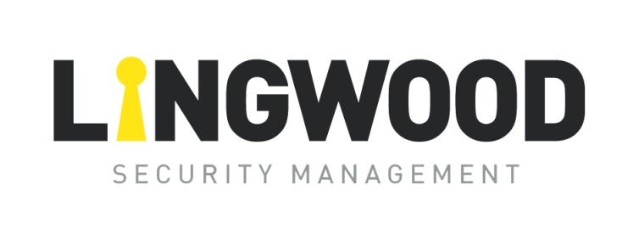

**GDPR Privacy Statement**

Lingwood is committed to ensuring obligations are met under the General Data Protection Regulations (GDPR). Whilst we do not operate a website containing the facility to collect, store or distribute personal information, we uphold our obligation to ensure the security and protection of personal information, held by us, within our control.

If we should ask you to provide information by which you can be identified, for the purposes of communication within projects undertaken by us, please be assured the information will be kept in accordance with this statement.

The information we hold about you will be determined by your relationship with us and may include the following:

* Personal I.D. - Name and Title.
* Contact Information - Address, E-mail, Telephone number.
* Business Information - Current and previous Project Detail.
* Information you have provided us as part of our Business Services or on Initial Contact.
* Information collected as part of our Engagement Practices.

Our use of personal information is to enable us to deliver services to our Clients. In order to undertake this service, it is necessary for us to collect and store your provided data.

We may contact you by; E-mail, post or telephone.

The following lawful conditions will be relied upon to process your identifiable data:

* To fulfil our obligations under a client engagement that we have with you or a third party.
* To satisfy legal or regulatory obligations we may be obliged to meet.
* In delivery of our legitimate business interests and effective performance of our services.

Lingwood does not; sell, trade or rent any personal information to other organisations. Your personal data is kept confidential and will only be used in accordance with instructions.

We may disclose your personal information to third parties under the following circumstances:

* At your request.
* To deliver documents or reference materials at your request or in line with project procedures.
* As necessary to facilitate events on your behalf.
* Compliance or Regulatory purposes.

We may, if required, disclose your personal information to regulatory, law enforcement or other government agencies, professional bodies and other third parties in accordance with applicable law or regulation or where our assets are acquired by a third party.

Your Personal information will be held on our system until such a time as you ask us to remove it, for example, following the completion of a project, as our clients often return to us for future projects and ventures.

All personal information is treated confidentially here at Lingwood. Accepted standards of organisational and technical security measures have been implemented to secure and protect it.

This policy will be reviewed annually.

Signed: \\lingsecdc01\Users\DOC\Desktop\Alan Jnr Signature.jpg

Date: 1st Apr 23

Alan Lingwood (Managing Director) Review Date: Mar 24