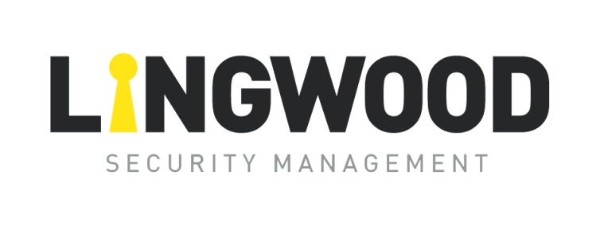

#### EQMS Policy Statement

Lingwood Security Management Ltd is committed to an operating philosophy based on openness in communication, integrity in serving our clients, fairness and concern for our employees and responsibility to the communities within which we operate.

Our vision is to exceed Client expectations for quality, safety, sustainability, cost, delivery and value. Additionally, we are dedicated to creating a profitable business culture that is based on the following principles:

**OUR PEOPLE**

Lingwood Security Management Ltd is committed to equality in employment opportunity and rewards, embracing wholeheartedly the cultural diversity within the communities we call home. Our employees’ welfare and interests are foremost throughout all aspects of our business and how we conduct our affairs. Lingwood Security Management Ltd is committed to:

* + - * 1. Creating and nurturing an environment of success based on honesty and integrity;
        2. Empowerment through training and communication;
        3. Individual growth and equal opportunity;
        4. Designing and providing a safe and secure work environment.

**OUR CLIENTS**

Client needs are paramount and represent the highest priority within our business. Our obligation is to proactively seek out and define Client needs while addressing all requests expeditiously without creating false expectations.

**OUR ENVIRONMENT**

Lingwood Security Management Ltd is committed to supporting the communities within which we operate. We believe in the practice of social responsibility and encourage similar behaviour in our employees and suppliers.

We support the conservation of the physical environment and the prevention of pollution at our facilities and as such, our environmental commitments include:

1. Protection of the environment;
2. Conformity to compliance obligations;
3. Continual improvement;
4. Prevention of pollution and sustainable use of resources;
5. Climate change mitigation and adaptation;
6. Protection of biodiversity and ecosystems;
7. Other specific commitment(s) relevant to our context.
8. Monitoring & Review of our operations with planned auditing and inspections of both operations and procedures to ensure compliance with our Management Systems and the Environmental Standard ISO14001:2015

We proactively comply with all applicable safety, environmental, legal and regulatory requirements to which we subscribe.

**OUR QUALITY**

Lingwood Security Management Ltd is committed to achieving competitive excellence and providing our Clients with projects and services designed, produced and maintained to meet or exceed their expectations by:

1. Complying with all Client, statutory and regulatory requirements;
2. Enabling employees to achieve business and professional goals;
3. Continually improving our processes via our EQMS;
4. Extending our EQMS practices throughout our Supply Chain.

Beginning with a clear definition of Clients’ expectations, we strive to consistently meet or exceed them. We adhere to the requirements of BS EN IO S9001: 2015 and Client specific requirements and endeavour to provide processes that ensure we achieve this in order to build a robust first class business.

Signed:

\\lingsecdc01\Users\DOC\Desktop\Alan Jnr Signature.jpg Date: 1st Apr 24

Alan Lingwood. (Managing Director) Review Date: Mar 2025