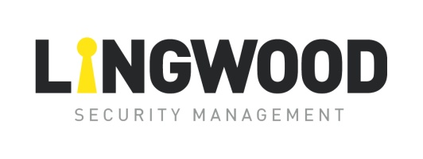

Lingwood Security Management Ltd. 6 Penrod Way, Heysham, Lancashire LA3 2UZ

Tel: 0845 450 5830 Fax: 0845 450 5831 Mobile: 07801 059 259

[www.lingwoodsecurity.com](http://www.lingwoodsecurity.com) Email: [sales@lingwoodsecurity.com](mailto:sales@lingwoodsecurity.com)

Company Registration No. 4170839 VAT No. 719 4889 80

**Lingwood Security MODERN SLAVERY TRANSPARENCY STATEMENT 2024**

This statement is made in accordance with the Modern Slavery Act 2015. It explains the approach Lingwood Security take as a company prevent modern slavery and human trafficking from occurring in its business and its supply chains.

**OUR BUSINESS AND SUPPLY CHAINS**

We base our approach to business on our five Cornerstones: keeping people safe, upholding family values, working for our customers, being the best and making decent returns. We communicate these both to our colleagues and suppliers as we believe it makes us different from our competitors. In essence the Cornerstones come down to doing the “right thing”, which is how we have approached the issue of Modern Slavery both internally with colleagues and with our suppliers.

**INTRODUCTION**

We understand that the issue of slavery and human trafficking is a global issue and that no business sector will be able to eliminate or be free of slavery within their supply chain without working collaboratively with industry and interested organisations. We take the approach that we will not accept slavery or human trafficking and will work with suppliers and colleagues to take positive steps to ensure that slavery has no place in our business or supply chain.

**POLICIES TO PREVENT SLAVERY AND HUMAN TRAFFICKING**

We require suppliers to take positive steps to ensure slavery and human trafficking is not present in their supply chains, at the same time undertake an risk assessment to help identify potential related risks in the supply chain.

**DUE DILIGENCE ACTIVITY ACROSS OUR SUPPLY CHAIN**

We have taken a risk based approach in considering our exposure to modern slavery, we recognise that an audit based system has its limitations and have also rolled out an awareness programme about the implications of Modern Slavery for our commercial and product supply colleagues who are most likely to be confronted with the issue in their dealings within the supply chain.

**2024-2025 TARGETS TO BUILD ON OUR APPROACH TO MODERN SLAVERY**

● Review the areas of concern highlighted through our Supplier Commitments programme and work alongside suppliers, customers and interested organisations to eliminate risk from our businesses and supply chain.

● Review our own audit programme and establish if this is the most effective way to support our approach to Modern Slavery.

● Review how we can be more effective in collaborating with both customers and suppliers to support our approach to Modern Slavery.

● Refresher training for all management to complete the Modern Slavery Training Module on skillcast

We will continue to develop our approach to tackling the issue of Modern Slavery, as issues may evolve and require a different approach as more information becomes available.

Alan Lingwood

Managing Director

\\lingsecdc01\Users\DOC\Desktop\Alan Jnr Signature.jpg

1st Apr 24