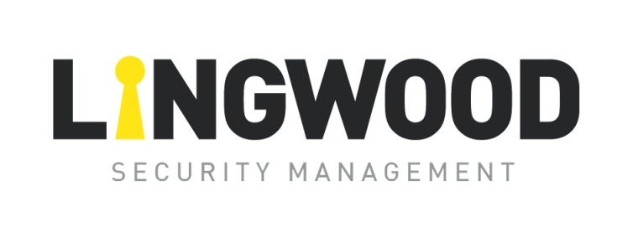

**Environmental Sustainability Policy**

Lingwood Security is custodian of grounds at the port of Heysham and is committed to maintaining the quality of this environment both for those that work within the company, its clients, and the wider community.

Lingwood Security takes its responsibilities seriously and undertakes to take significant and lasting steps to minimise adverse environmental impacts and to conserve natural resources in its activities.

**Lingwood Security:**

* Has had a full carbon assessment carried out of our business premises and practices, by the McCAW project team.
* Has made use of technology to reduce the need for face-to-face meetings (Microsoft TEAMS & ZOOM)
* Has an active policy of recycling wherever possible? All waste is recycled appropriately including bottles, paper, cardboard, grass, and wet waste. All suppliers and clients are encouraged to do the same.
* Places paper recycling bins in all meeting rooms when in use.
* Seeks to minimise the use of non-renewable resources.
* Monitors and analyses energy usage with the aim of reducing consumption where possible.
* Has replaced light fittings with low energy fittings throughout our business premises.
* Has installed solar panels on our premises to reduce our carbon footprint.
* Has had electric vehicle charging points installed.
* Has started replacing our vehicle fleet with electric and hybrid vehicles, this is a 3-year rolling plan.
* Holds regular meetings to raise environmental awareness amongst staff and others.
* Avoids unnecessary water usage.
* Avoids unnecessary distribution of printed paper.
* Makes its best endeavours to ensure that cleaning materials are biodegradable and environmentally friendly.
* Encourages the use of public transport for staff
* Encourages car sharing and the bike to work scheme
* Has an active planned maintenance programme to reduce the environmental impact of activities within the company and conserve energy where possible.
* Holds ISO 14001 Accreditation and works to improve processes following external audits annually

Signed:  Date: 1st Apr 24

Alan Lingwood. (Managing Director) Review Date: Mar 2025